1. Project Overview
The Citizen Complaint Management System is a Python program that demonstrates object-oriented programming while addressing a government service problem. Citizens can report issues such as damaged roads or missed waste collection. The prototype records each complaint, assigns it to a suitable department, tracks its status, and displays the records.
This assignment project uses fictional examples from Central Freetown and Lumley. It is an educational prototype; it does not connect to a government database or collect sensitive personal information.

2. Project Objectives and Requirements
• Represent complaints and departments with at least two Python classes.
• Create objects and demonstrate interaction between a complaint and a department.
• Store multiple complaint objects in one dictionary using each complaint ID as the key.
• Provide functions to add and display complaint records.
• Use instance and class methods; also include a static method to validate complaint statuses.
• Explain how the project supports the Digital Public Goods principles in its README and documentation.

3. Class and Object Design
The Complaint class is the blueprint for an individual complaint. Its attributes are complaint_id, category, area, description, status, and department. New complaints begin with Pending status and an Unassigned department. Its instance methods display details, update a valid status, and assign a department.
The Department class is the blueprint for a government department. It stores department_name and supported_category. Its receive_complaint() method checks a complaint category and assigns the complaint when the department supports that category.
The program creates two complaint objects and two department objects. The Roads Department receives the Roads complaint. The Waste Department receives the Waste Collection complaint.

4. Data Structure and Methods
A dictionary named complaints stores Complaint objects. Each complaint ID, such as C001, is the key, and the Complaint object is the value. The add_complaint() function adds a record if the ID is not already in use. The display_all_complaints() function loops through the dictionary values and displays each record.
The class method get_total_created() reports how many Complaint objects were created. The static method is_valid_status() checks for Pending, In Progress, or Resolved. The instance method update_status() uses this check before changing a complaint status.

5. Digital Public Goods Alignment
Open source: The project includes an MIT License and shares its source code so that others can read, run, adapt, and redistribute it under the license terms.
Inclusive and accessible design: The program uses plain-language labels and simple console output. It runs with standard Python and does not require paid tools or third-party packages.
Privacy-respecting: The program does not ask for a person’s name, phone number, password, or other sensitive personal information. The sample records are fictional. Users should not enter personal or confidential information in complaint descriptions.
Modular and reusable: Complaint and Department responsibilities are separated into classes. Functions manage adding and displaying records, and the methods can be reused in a larger prototype.

6. Sample Usage and Test Result
Run the program from a terminal with the command: python citizen_complaints.py. The demonstration creates complaints C001 and C002, assigns departments, adds both objects to the dictionary, updates C001 to In Progress, and displays the stored records.
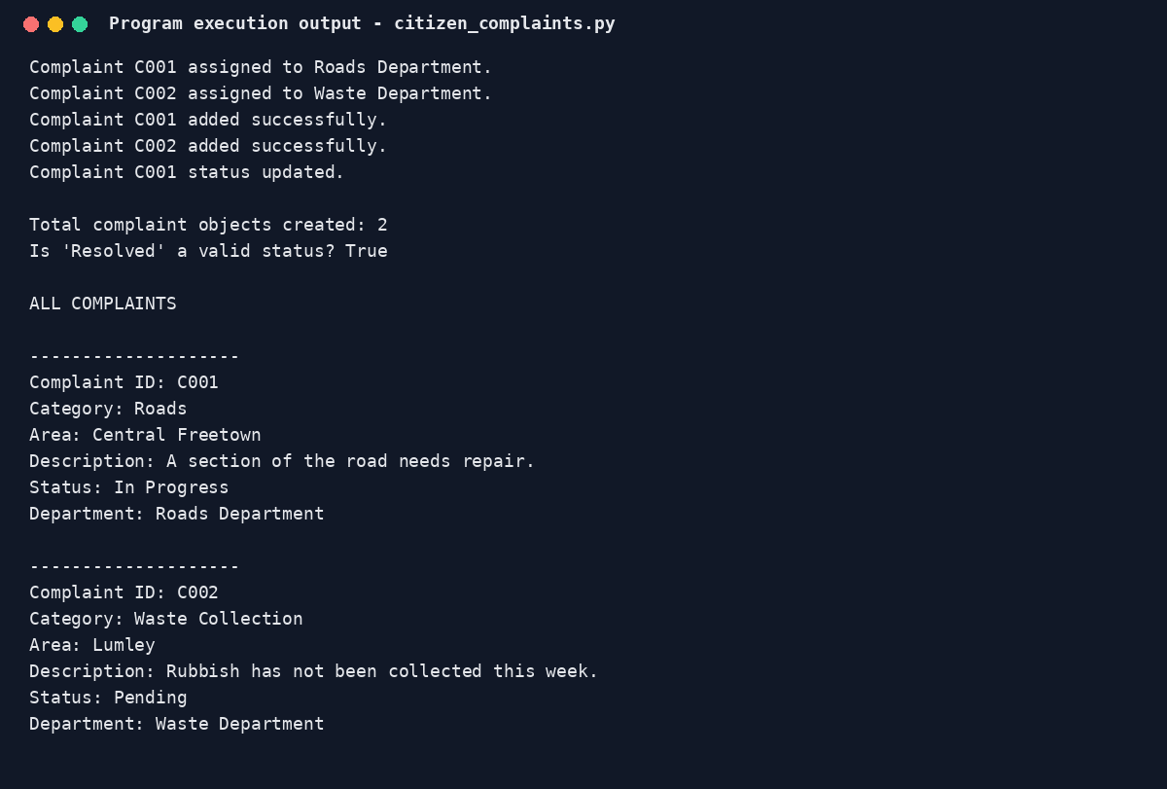
Figure 1. Console output from the tested program run.

7. Limitations and Conclusion
Records disappear when the program closes because they are stored only in memory. The prototype has no login or permanent database and is not connected to a government department.

